1. Pull down latest Schavn and HapiSpike code from SVN. Cornerstone is already setup to pull it down I believe.

dev.sftsrc.com/REMD/HapiSpike

dev.sftsrc.com/REMD/Scavhn

1. Verify HapiJS project runs. This is the NodeJS REST server.
   1. Open HapiJS directory in WebStorm
   2. Nav to index.js file
   3. Get the machine’s IP. Easiest way to do this is to go to

System Prefs > Sharing. The main part of the dialog should look like:

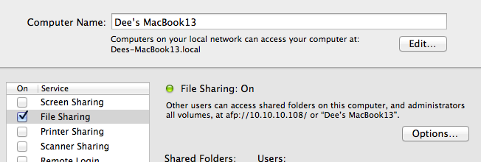

The IP is in that “File Sharing: On” section.

* 1. In the index.js file, change the

var server = Hapi.createServer('10.10.2.128', 8000, { cors: true };

line near the top to use the IP you found for the machine in the first createServer arg.

* 1. Open Terminal and navigate to the root of the HapiSpike folder.
  2. At a command line, type node . and return. That will fire up the REST server.
  3. Test it by going into WebStorm and going Tools > Test RESTful Web Service. Set the path to <http://[IP]:8000/scavhn/scavs> and do a GET. You should see a 200 with some JSON data coming back.

1. Crack open the Scavhn project in Xcode. Compile it and run it. It won’t work at first because you now have to set the REST server it is pointing to. Go back into WebStorm, and open the web portion of the Scavhn project. If you navigate into the Scavhn project folder, it’ll be at /Scavhn/Scavhn/web/scavhnapp/settings.js. Change the servicesBaseUrl value to the correct IP.
2. You gotta change the ip in one more place for the native container. In Xcode, find the Settings.Bundle file under Supporting Files. Open it and go to Root.plist. In the main view, expand “Item 3 (Text Field – Domain). Change the default value to the correct value for the server. Next time you fire up Xcode, Scavhn should work. You may need to do a Run > Clean and “Reset Content and Settings” in the iOS sim to un-gum the original settings, but that should do it
3. Shut down Xcode and fire up AppCode. Verify you can run the project in AppCode.
4. Shut down AppCode and Fire up WebStorm if you don’t still already have it up. In the project pane, right-click on the index.html file and select “Open in Browser” near the bottom. It’ll fire up the index HTML and it will run it in a little Tomcat instance. You should be able to see the homescreen that way in the desktop safari browser.